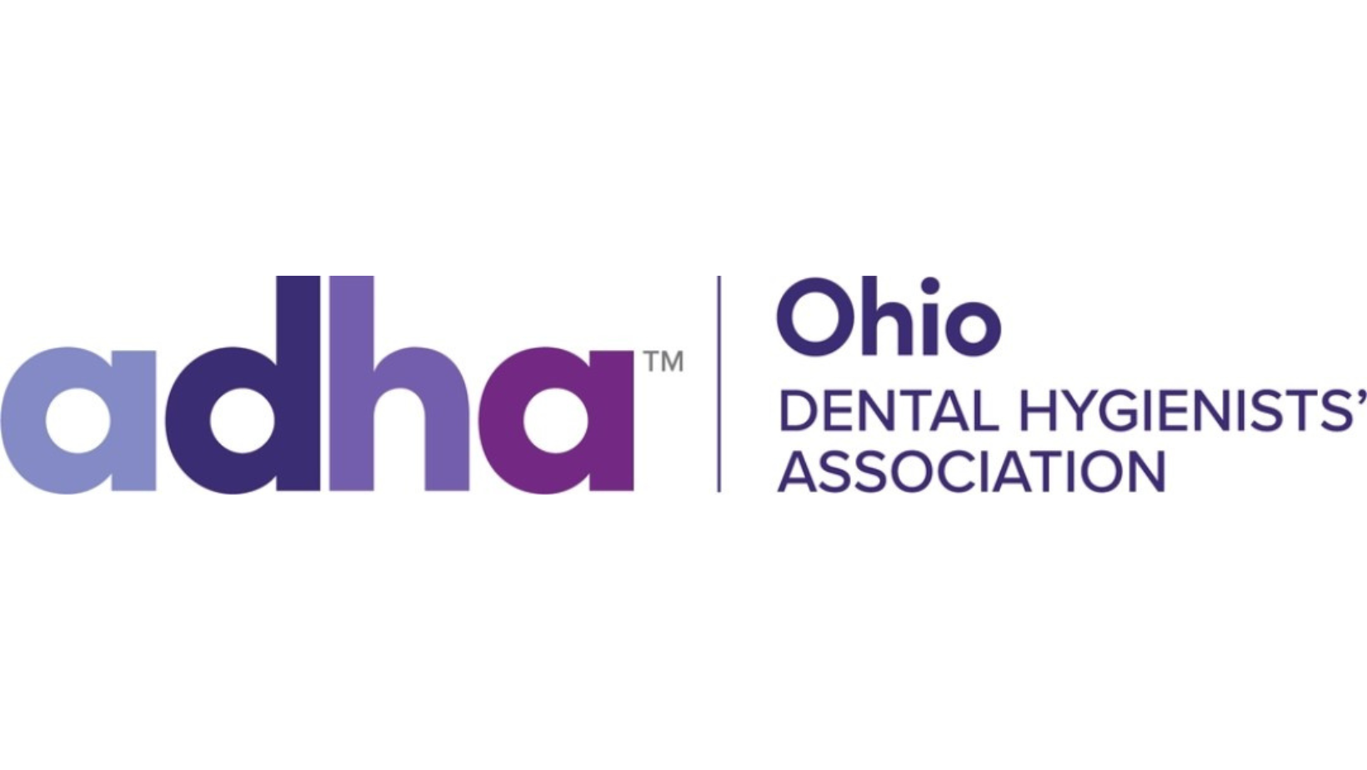

# **ODHA PROPOSED RECOMMENDATION HOD 2023**

BE IT RESOLVED THAT ODHA:

JUSTIFICATION:

## Submitted by:

Person to contact:

Email:

Cell Phone:

Determination of Policy & Bylaws Council:

__ Finds acceptable for consideration

__ Makers were asked to withdraw

__ Considers inappropriate as administrative or procedural matter

__ Considers this an ongoing procedure

__ Considers in conflict with Bylaws

__ Considers in conflict with existing Policy

__ Considers this a duplication of current Policy

Action recommended by the Board of Trustees:

__ Adopt __Refer __ Reject __ Amend

Email completed form to [madmattyrdh@gmail.com](mailto:madmattyrdh@gmail.com) by 11:59pm on September 1, 2023. The Council must be able to contact the individual listed on September 9, 2023, between the hours of 10am-5pm. That person must have the authority to act upon the committee’s questions or recommended actions and will be responsible for communicating results of the call to all makers listed. **If the council is not able to contact the person listed on the PRec, it will be removed from consideration.**