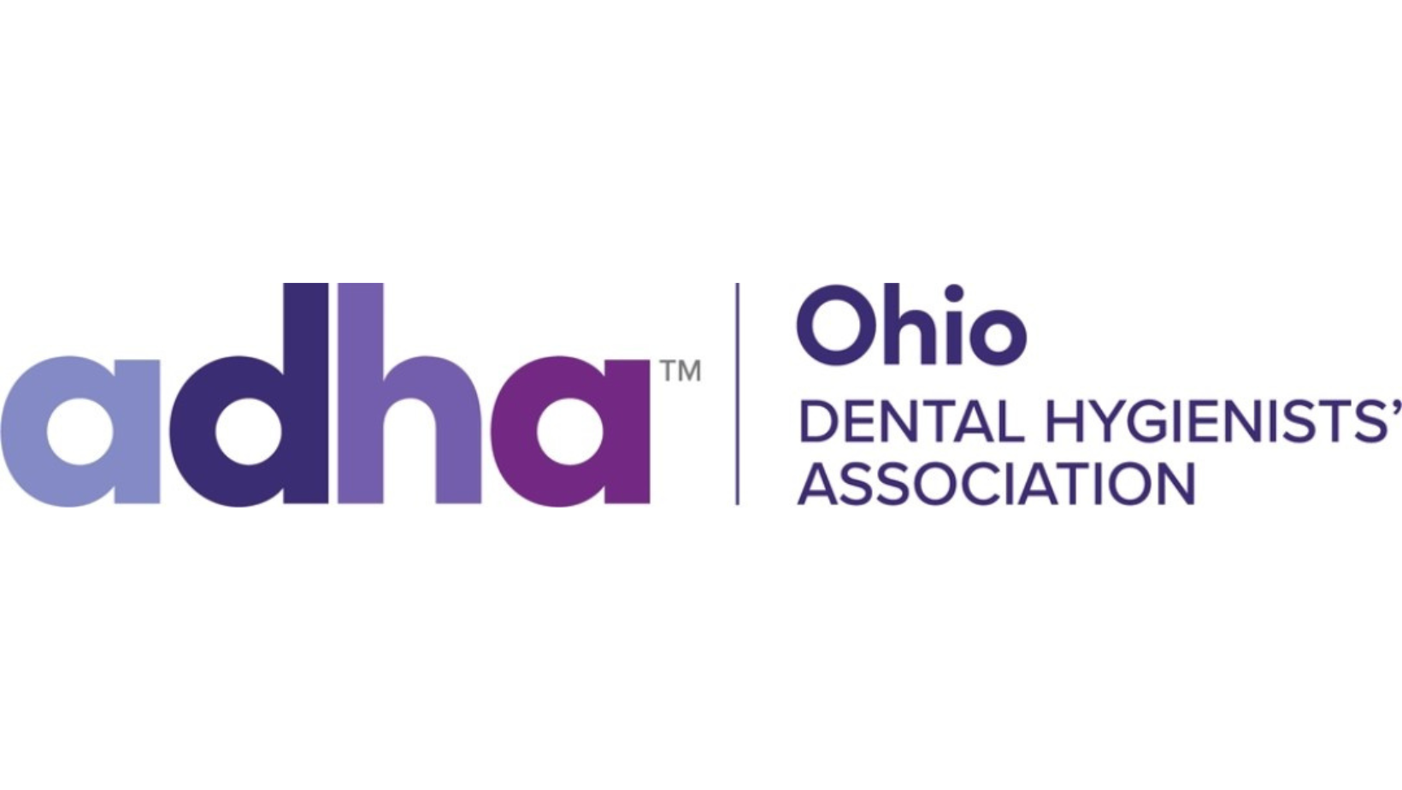

ODHA PROPOSED RESOLUTION/ BYLAW AMENDMENT HOD 2023

BE IT RESOLVED THAT ODHA:

JUSTIFICATION:

Submitted by:

Person to contact:
Email:
Cell Phone:

Determination of Policy & Bylaws Council:

__ Finds acceptable for consideration
__ Makers were asked to withdraw
__ Considers inappropriate as administrative or procedural matter
__ Considers this an ongoing procedure
__ Considers in conflict with Bylaws
__ Considers in conflict with existing Policy
__ Considers this a duplication of current Policy

Action recommended by the Board of Trustees:

__ Adopt __Refer __ Reject __ Amend

Email completed form to madmattyrdh@gmail.com by 11:59pm on September 1, 2023. The Council must be able to contact the individual listed on September 9, 2023, between the hours of 10am-5pm. That person must have the authority to act upon the committee’s questions or recommended actions and will be responsible for communicating results of the call to all makers listed. If the council is not able to contact the person listed on the PR/PBY, it will be removed from consideration.

