**Ohio Dental Hygienists’ Association Informative Poster Application**

Application Deadline: October 7, 2023

Please read the Informative Poster Guidelines before completing the application. All information must be completed in full before any application can be accepted. Contact [ODHATableClinics@gmail.com](mailto:ODHATableClinics@gmail.com) with any questions.

This year we are offering the option of being judged to presenters. It is our sincere hope that all presenters will follow ADHA Guidelines, whether you are being judged or not.

Please indicate below whether you wish to be judged.

Yes, please include my Informative Poster in the judging

No, I do not wish to be judged

**Presenter Information** Up to four presenters are allowed per presentation. College/University:



**First Presenter (Primary Contact)**

ADHA Member ID:



Name:



Phone:



Email:



**Second Presenter**

ADHA Member ID:



Name:



Phone:



Email:

**Third Presenter**

ADHA Member ID:



Name:



Phone:



Email:



**Fourth Presenter**

ADHA Member ID:



Name:



Phone:



Email:



**Student Advisor**

Name:



Phone:



Email:



**Program Director**

Name:



Phone:



Email:



**Presentation Information**

Title:



Objective:



Abstract/Summary:

Click or tap here to enter text.

Your presentation will be evaluated on the objective and abstract. Please remember that failure to comply with the rules and regulations, as well as criteria set forth in the “Research Poster Guidelines” document, will disqualify the presentation from active competition. This information can be found on ODHA’s website [www.odha.net/students](http://www.odha.net/students).

I hereby release and agree to hold harmless the Ohio Dental Hygienists’ Association and the proprietor and operator from any and all liability for damages or loss to my goods or property while located on hotel premises. Electronic submission will accept the selection of this item as your signature.

Name:



Date:



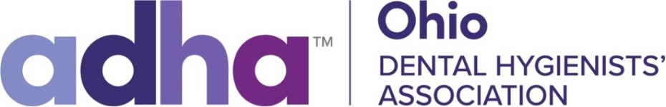

**Ohio Dental Hygienists’ Association 2023 Student Reception**

The 2023 Student Awards will be presented at the Student Awards after the Poster Session/Cornhole Competition on Saturday, November 4th, at 4:30 pm in the Ohio Event Center. Please indicate below the **one** advisor or program director designated to attend the Awards ceremony with your group. Family and friends may also attend but will be seated in the rear of the reception hall.



Name:



Title:



Phone:



Email:



Number of Student Presenters Attending:

Please return this form by **October 7, 2023.**

You may submit applications to: [ODHATableClinics@gmail.com](mailto:ODHATableClinics@gmail.com)