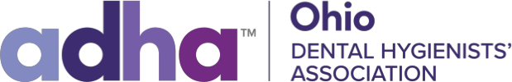
Clifford Jones Memorial Outreach Grant
The Ohio Dental Hygienists’ Association is offering a $250.00 grant which will be awarded at the 2024 Ohio Dental Hygienists’ Annual Session state meeting, to a member dental hygienist who has provided, or plans to provide, free dental hygiene services and/or education to the underserved. Please complete the application and mail or email to:
Clifford Jones Memorial Outreach Grant
Brittany Moore, MDH, Committee Chair
6480 Coldwater Creek Drive
Findlay, Ohio 45840 Brittany_Moore4@owens.edu
The grant application must be received by October 1st, 2024
Purpose
The grant award recognizes and supports a program that delivers pro bono dental hygiene services to the underserved or at-risk populations.
1. Membership in the Ohio Dental Hygienist Association
2. Description of the program including:
a. If it is a current program, how long has it been in existence?
b. If it is a startup program, what is the target start date?
c. Who is the target population?
d. What type of dental hygiene services or education is or is going to be provided?
e. How many volunteer hours have been or is going to be provided?
3. If awarded this grant, what will the money requested going to be spent to purchase?
The recipient of this award will be asked to report back to the House of Delegates regarding how this money was utilized and the success of the program. This information will be shared with membership via ODONTIA and the Ohio Dental Hygienists’ Association’s website.
Application
Name_____________________________________________
ADHA member number______________________________
Phone number _____________________________________
Ohio Component ___________________________________
In 500 words or less, please describe the project including sponsoring organization(s)

