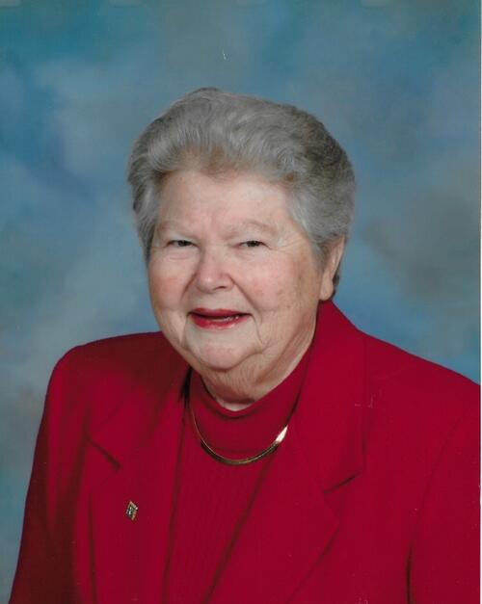

LOUISE M. BARRETT STUDENT SCHOLARSHIP 2024
Louise M. Barrett was passionate about the profession of dental hygiene the moment she graduated from The Ohio State University in 1958 and received her dental hygiene license. Prior to attending college, Louise proudly served two years in the U. S. Air Force. Louise was a past president of the Dayton Dental Hygienists’ Association and a two-term past president of the Ohio Dental Hygienists’ Association. She also served many years as Sergeant of Arms for the Ohio Dental Hygienists’ Association. As a respected ODHA member, she was elected to serve as Delegate to ADHA numerous times. She befriended and mentored many dental hygienists throughout the state. Her laugh, smile, friendship, and never knowing a stranger was her gift to all of us.
Description of Louise M. Barrett ODHA Student Scholarship:
Established in 2018, this scholarship honors Louise M. Barrett, RDH, for her years of service and contribution to the profession of dental hygiene. Applicants must be enrolled in an Ohio associate or baccalaureate dental hygiene program and must have completed a minimum of one year; be a student member of the American Dental Hygienists’ Association; display an overall cumulative grade point average of at least a 3.0 on a 4.0 scale; demonstrate personal and professional qualities reflecting those of Ms. Barrett. Applications for this annual scholarship must be electronically submitted by the stated deadline to the current ODHA Chairperson of Student Council. This scholarship will be awarded at the ODHA Annual Session.
OHIO DENTAL HYGIENISTS’ ASSOCIATION LOUISE M. BARRETT STUDENT SCHOLARSHIP 2024
Purpose
This annual ODHA student scholarship is in memory of Louise M. Barrett, RDH, Past President of ODHA. Louise was totally committed to the advancement of dental hygiene throughout her dental hygiene career. The 2024 scholarship is in the amount of $1500.
Selection Criteria
1. Scholastic ability (3.0 minimum on 4.0 scale)
2. Professionalism
3. Financial need
4. Student membership in ADHA
5. Service towards country, community OR family

Procedure
Second year (associate degree program) senior year (baccalaureate degree program) Ohio dental hygiene students may apply for the scholarship. The application must be electronically completed and submitted electronically to the contact listed on the application. Email deadline for submission is October 1st, 2024. ODHA scholarship selection committee will mask all applications. Criteria Review forms will be utilized for standardization. ODHA Student Council chair or appointee(s) from the council will tally the scholarship committees’ responses to determine the scholarship recipient. The scholarship will be awarded by Student Council chair or representative at the ODHA Annual Session.

APPLICATION OHIO DENTAL HYGIENISTS’ ASSOCIATIONS’ LOUISE M. BARRETT STUDENT SCHOLARSHIP
All applications must be submitted in type print using the electronic format of this application by October 1st, 2024. Handwritten or jpeg documents will not be accepted.
Email to: connietooth@gmail.com
Connie Clark, Chair of Louise M. Barrett ODHA Student Scholarship

Applicant’s Name_______________________________________________________________________
Last First Middle

Home Address________________________________________________________________________
Street

______________________________________________________________________________
City State Zip Code

______________________________________________________________________________
Email address

______________________________________ __________________________
Phone Number SADHA membership #

School Name__________________________________________________

Address______________________________________________________________________________
Street

_____________________________________________________________________________________
City State Zip Code
Please respond clearly to following questions. Reviewers will pay close attention to sentence structure, grammar, and spelling and overall continuity of all remaining sections; points will be deducted for errors.
Overall cumulative GPA (4.0 scale): _____________
Total dental hygiene credit hours completed: _____________
Dental Hygiene Semesters completed: ________________
- Describe your plans for furthering your education or not. Explain how this choice may impact your future as a licensed dental hygienist.

2. Define professionalism. What does professionalism mean to you and why is it important?

3. Describe how the monies from this scholarship would be used.

4. Describe your experiences with your professional organization.

5. Service to others. Describe your service to country, community, OR family. What has been the impact of your service to others?

Application Verification:
I certify that I have read the completed application for accuracy. I understand that this material is confidential and will be seen only by the members of the Scholarship Selection Committee and the Administrative Assistant of the Ohio Dental Hygienists’ Association.

__________________________________________________________ ____________________
Student Signature Date

Student Chapter of ADHA Advisor verification:
I hereby verify that this student applicant is a Chapter member and has accurately reported his/her GPA.

__________________________________________________________ ____________________
Student Chapter of ADHA Advisor Signature Date

