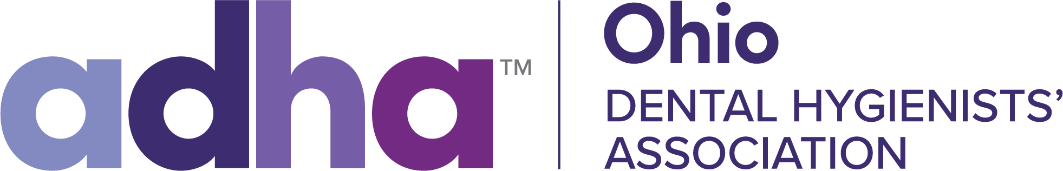

ODHA OUTSTANDING EFFORT AWARD 2024

This award is designed to honor a selected member or ODHA Committee who has best exemplified outstanding service to the Ohio Dental Hygienists' Association during the 2023-2024 fiscal year. An individual or Committee may be nominated for this award if the following criteria are met:
1. Membership on the ODHA Executive Board, Board of Trustees, ODHA Council, and/or ODHA Committee.
2. Attendance at the 2024 ODHA Annual Session.
3. Attendance at no less than three (3) Board of Trustees meetings during 2023- 2024.
4. Participation in at least one (1) ODHA sponsored workshop and/or continuing education program during 2023-2024.
5. Volunteers time and effort "beyond the call of duty" to further advance the profession of Dental Hygiene in Ohio.

It is necessary to include a written testimonial of why you feel this member or committee is deserving of this award, using the criteria listed above.

The deadline to submit award applications is 10/01/2024.

Please submit to:
Shannon Sweeney, RDH
shanahanrdh@gmail.com

Thank you for your service to ODHA!

