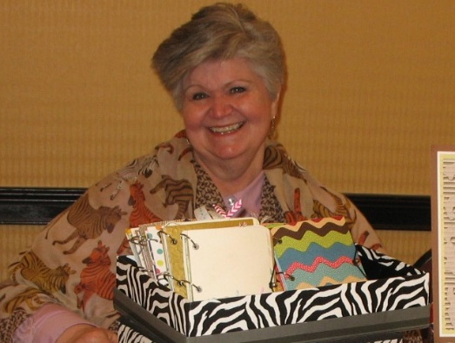**Sandra L. Winchell**

**Exemplary Service Award**

A professional organization is only as strong as the commitment of its members to the organization’s success.

While it is often the leaders of an organization that are rightfully given credit for its achievements, it requires other dedicated members who selflessly give of themselves in supporting roles for the plans of the organization’s leaders to reach fruition.  
  
For the efforts of these unsung members, the Sandra L. Winchell Exemplary Service Award has been created in Sandy’s name. This award was created to honor her longstanding commitment to ODHA, her timely use of her creative talents to benefit ODHA, and her lasting impact on the image and reputation of ODHA.

The recipient will be recognized during the ODHA Annual Session and be presented a monetary award of $500.00 made possible through a generous contribution by Sandy’s husband Jerry Winchell.

**Criteria for nominating an ODHA member for the award are as follows:**

1. Fifteen plus years of ODHA membership.

2. Exceptional voluntary service to ODHA through participation on committees, programs, legislative efforts and/or community outreach efforts.

3. Attendance at the current year’s ODHA Annual Session.  
4. A written nominating statement from another ODHA member detailing why the member’s contributions merit consideration for this award.  
5. Nominees may not currently hold **voting** positions on the ODHA Executive Council or ODHA Board of Trustees.

**Deadline for submitting nominations is October 1st, 2024**

Please submit nominations to:

Lainey Foster, RDH, BS

admin@odha.net